**Neuroscience Communication Course – notes**

**Colour vision**

Color: Cones (S, M, L type) 🡺 maximum absorbance for S cones = 455 nm, maximum absorbance for M cones = 535 nm, maximum absorbance for L cones = 563 nm.

S is in blue/violet range, M is in greenish range, L is in reddish range. Eyes do not pass on unique wavelength information. Same response can be induced by either a wavelength lambda or another wavelength lambda_2 with increased intensity. Comparison of input in different levels takes place to generate colour eventually. Cones have a good and better time resolution than rods.

Rods close to 500 nm. Only activated in night vision, since they are fully saturated during day vision. They register every light quantum (highly sensitive).

Cones evolved first, so they are evolutionary more fundamental. Animals are normally tetrachromats. In humans, trichromatic vision re-evolved, as some new world monkeys for example are still dichromats. Trichromatic vision evolved from a duplication of M cone genes that after mutation became L cones, which is why they are so similar. Human blue cones come from UV opsins, but it was shifted into being functional in the blue range.

Dichromatic boys prevalence is 8% due to unequal crossing-over and X-chromosome linkage. Females typically have two different M cones being expressed (one on each X chromosome) which results into their fovea being a genetic mosaic. There are also tetrachromatic females due to a duplication in M cone genes. The opsin molecule has maximum absorbance between M and L cones and these female are capable of perceiving yellowish colours that are indistinguishable for trichromats.

Colour is not a physical property, but a brain generated qualia. Photoreceptors only count photons, colour is produced in hierarchically higher brain areas somehow. For instance, comparison of at least two photoreptor inputs is needed to produce colour.

Protanopia 🡺 lack in L cones, no red vision.  
Deuteranotopia 🡺 lack in M cones, no green vision.

ON pathway 🡺 in the center, such ganglion cells are activated by light and fire.  
OFF pathway 🡺 in the center, such ganglion cells are inhibited by light and do not fire.

Comparison between colour changes already takes place in the retina. Inputs from different cone cells produce colour in the following manner: (L – M) input = red-green perception, (L + M – S) input = blue-yellow perception, (L + M) input = luminance (levels of grey).

Next stage in colour processing happens in the LGN. The LGN is made up of 6 layers: 4 parvo layers and 2 magno layers and 6 konio layers in between the other two layers.

Parvo layer 🡺 M and L cones, perception of **colour** and form.  
Magno layer 🡺 rods; perception of movement, depth and luminance changes.  
Konio layer 🡺 S cones.

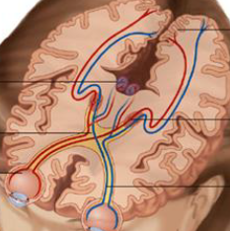Dorsal path processes the where information (motion, location). The ventral path processes the what information (form, colour).

Pathway: lens, photoreceptors, ganglion cell, optic nerve, optic chiasm, LGN, V1, higher areas. After the optic chiasm, some information also goes to the superior colliculus.

LGN projects ipsilaterally, ganglion cells project ipsi- and contralaterally.

**Apoptosis in neurons**

During development, many neurons die. Casp3 is an apoptotic marker and appears red when stained.

**Morphological changes in neurons undergoing apoptosis**: cell shrinks and chromatin condenses, membranes starts to bleb and organelles disintegrate (here, cytochrome c is released), more blebbing and collapse of nucleus and organelles, formation of apoptotic bodies followed by phagocytosis of these bodies by macrophages. **No** inflammatory response! Natural apoptosis is anti-inflammatory.

Pro-inflammatory responses are necrosis and programmed necrosis. In necrosis, the cellular contents are released.

During apoptosis, initators activate executioners to remove key structure proteins.  
Pro-apoptotic proteins: BAK and BAX, BAD, PUMA and Noxa.  
Anti-apoptotic proteins: BCL-2, BCL-x, BCL-w.  
Intrinsic pathway is via Casp3, extrinsic pathway is via ligands and receptors.

Neurotrophin family: NGF, BDNF, NT3, NT4. These bind to a receptor and signal survival retrogradely. If these are not in the vicinity of a neuron, then the neuron does not receive a survival signal and dies eventually (does apoptosis). These belong to the tyrosine receptor kinase family.  
p75NTR can bind all the 4 survival factors, but with lower affinity.

After NGF withdrawal, it takes around 24-48h for apoptosis to complete (cytochrome c release after 16h). PI3K/Akt pathway inhibits Bad and FOXO that are pro-apoptotic, as long as NGF binds to TrkA and signals (as an example). This pathway activates Akt which inhibits apoptosis by inhibiting FOXO and Bad and activate ERK1/2 that promote Bcl-2 which is anti-apoptotic.

Microglia cells can promote apoptosis in neurons in the developing brain and they also remove the neural debris afterwards. There is a maximal number of cortical neurons that the brain can accommodate. Neurons die during development when no longer needed, harmful or defective. In the developing brain, neural removal serves the function of optimizing pathways and networks such that brain size is kept minimal, but neurons are sufficient.

**Pain**

Nociceptors are located in the DRG or in trigeminal ganglions in the face. A spinothalamic neuron receives input from these nociceptors. Glutamate is the main neurotransmitter. TRPV1 is such a nociceptor, but it is also intrinsically sensitive to heat. TRPV2 is sensitive for T > 50°C approx. It is important to note, that nociceptors signal to the brain, but they also receive signals from the brain.

Nociceptive afferent fibers: peptidergic C fibers, non-peptidergic C fibers, A-delta myelinated fibers, A-beta myelinated fibers.

It seems that C fibers are the second, longer pain, while A-delta fibers are the first pain sensation, but it is much shorter.

Reasons for hyperalgesia: Changes in nociceptor sensitivity increases pain sensation (primary hyperalgesia) and hyperexcitability of dorsal horn neurons underlies centrally mediated hyperalgesia. With increasing stimulus intensity, subjective pain feeling is equally high in normals and hyperalgesia.

On the other hand, TRPV1 can adapt to a longer exposed pain stimuli, such that it desensitizes. Also, inhibitory neurons such as GABAergic or glycinergic neurons are involved in centrally mediated hyperalgesia, since their loss increases pain sensitivity.

Gate control theory: In the spinal cord, nociceptive and non-nociceptive fibers can modulate pain. Non-nociceptive fibers can inhibit the transmission of nociceptive fibers.

In the descending system, direct electrical brain stimulation can act as an analgesic via endogenous opioids.

Capsaicin is agonist for TRPV1. Pain can also be modulated by inhibiting certain factors in the inflammatory soup, such that pain is not signalled. Aspirin inhibits an enzyme needed for prostaglandin production.

**Brain energy metabolism**

Consciousness is lost after 10 seconds of interruption of blood supply and irreversible neural damage occurs after 1 minute of interruption due to ischemia or anoxia. Blood brain barrier is a physical barrier impermeable for most substances except for gases and some lipophilic substances. It has a very dedicated import system. Fats have to be de novo synthesized in the brain.

Glucose is the main energy metabolite which the brain mainly consumes in great numbers. Also, 160 mmol per minute are used by 100g brain tissue. Under certain conditions, ketone bodies can be generated to compensate for absence of glucose, such as acetone, acetoacetic acid and beta-hydroxy-butyric acid.

PET measures brain activity by injecting 15O (radioactive), which produces positrons. These are annihilated and gamma rays can be observed. Alternatively, one can inject F2-deoxyglucose. This method is invasive.

fMRI is a non-invasive method, which works by aligning paramagnetic atoms.

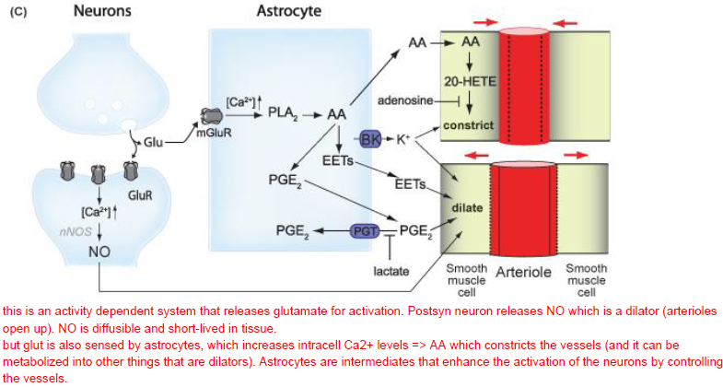

Glutamate from neurons is transported to astrocytes, where it is metabolized to glutamine and transported to the neuron, where glutaminases again remove NH4+ This regulates glycolysis and glycogen formation in astrocytes is regulated by neuronal activity.

**Sensorimotor integration**

Eyes pick and highly analyse interesting parts about a face, such as nose, eyes and ears. We say, these areas are **salient**, since a lot of computation power is invested there.

Eye muscle pairs (always antagonistic): lateral and medial rectus (to the periphery, to the middle of the face), superior and inferior rectus (up, down), superior and inferior oblique. These muscles are the fastest and they cannot fatigue.

Types of eye movements: stabilizing are the vestibulo-ocular movements (efficient for high speeds) and optokinetic eye movements (efficient for slow speeds). There are reflexes and not under our conscious control. Shifting are saccades, smooth pursuit and vergence. Vergence also gives absolute distant information.

Vestibulo-ocular reflex is that a fixed object remains at the same position when the head is turned, such that the eyes turn the other way. The optokinetic reflex simply follows a stimulus without turning the head and when it disappears out of the its range, they jump back again where they started following it (this is the jumping that you see when someone looks out of the window in the train). Saccades jump very fast from one object to another object. Smooth pursuit is the ability to smoothly perceive a moving object by continuous change in eye position.

Neuronal control is realized by both activation and inhibition of muscles. The primary motor cortex and frontal eye field brain area are important centers for eye movement amongst others. The superior colliculus also guides our eye movements. It is roughly divided in a visual layer and a motor layer that, for example, produces a saccade response.

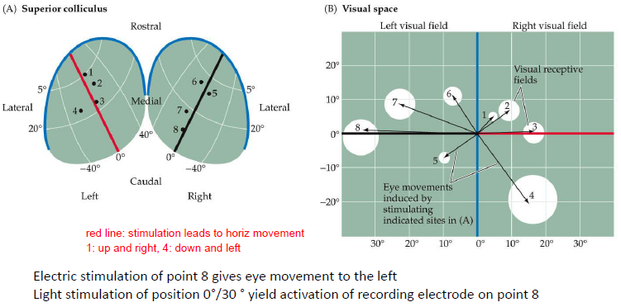

**Circadian regulation**

Facts about circadian rhythms: 9 p.m. is melatonin release (comes from PVH), 2 a.m. is the deepest sleep, 9 a.m. is WC time, around 3 p.m. is highest reaction time, coordination and physical performance.

Zeitgebers are external signals that provide us with information about the day and thus influence the circadian rhythm. Zeitgebers are sun light (most important one), but also caffeine, exercise, sounds etc. When sun light is removed, the circadian clock is retained, but shifted. Entrainment to sun light occurs with the melanopsin in ipRGCs, which is sensible to sun light (not involved in vision though). This way, also blind people retain this information. The signal is conducted to the SCN. Due to the sensitivity of rods in darkness, they also drive photoentrainment. Melanopsin is not sensitive in darkness.

The SCN is the central pacemaker for the circadian clock. Glutamate and NMDAR are needed for light impression.  
PER-CRY goes to nucleus and inhibits CLOCK AND BAML1 to inhibit E-Box, s.t. PER and CRY transcription is inhibited. This is a 24h rhythm. Many genes are controlled by whether CLOCK and BAML1 are cytoplasmic or nucleic and are influenced by their rhythm.

Melatonin is produced in the pineal gland. SCN: GABA is the neurotransmitter during the day. PVN is therefore inhibited. During the night, GABA release goes down. Other peripheral oscillators such as the liver and the kidney also influence the circadian rhythm. One can also entrain to specific food times, such that one becomes hungry always at approx. the same time. Signalling is mediated with the extra-SCN (food, food is also the 2nd most important entrainment object).

Diseases: per2 is involved in familial advanced sleep phase syndrome, night shifts increase risk of cancer due to melatonin impairment as well as per3 and per1 etc. involvement. Metabolic diseases are influenced by Clock and Bmal1.